**Labaratory Work 7**

**Student:** Adil Zhexenov

**Group:** SE-2101

First of all, I created a new database, which called ‘lab7’ and new ‘employees’ collection

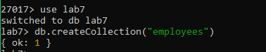

Then, I imported file ‘employees.json’ to this collection

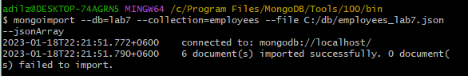

Task 1) Updates an id=1, firstName field in a single document in employees collection to “Nariman” and add the location field as “Aktau”.

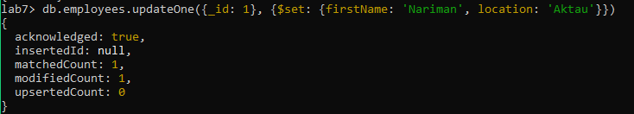

|  |  |
| --- | --- |
|  |  |
| Before | After |

Before the second task, we had to change the type of ‘salary’ field from String to Number, because in the second task we needed to use the $inc operator, but this operator doesn't work with a non-numeric type.



|  |  |
| --- | --- |
|  |  |
| Before | After |

Task 2) Increase the value of the salary field for firstName: “Elaman” by 500.

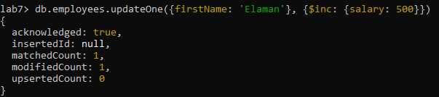

|  |  |
| --- | --- |
|  |  |
| Before | After |

Task 3) Updates email and lastName fields for id=2 as lastName= Turganbay, email=elaman.turganbay@abc.com

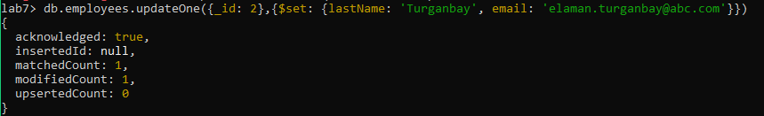

|  |  |
| --- | --- |
|  |  |
| Before | After |

Task 4) Overwrite array elements for skills of id=5 as "Sales Tax"

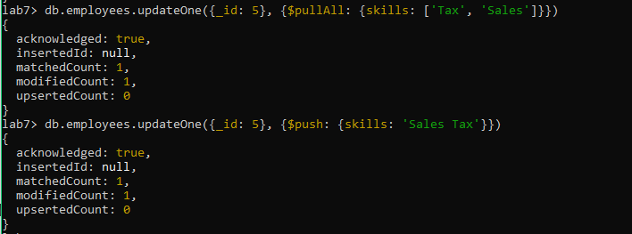

|  |  |
| --- | --- |
|  |  |
| Before | After |

Task 5) Add department with name= 'Finance', location= 'Astana' information to id=5 and update document

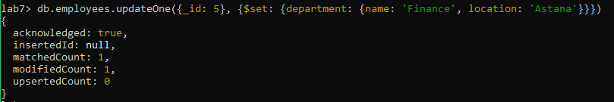

|  |  |
| --- | --- |
|  |  |
| Before | After |

Task 6) Update "Marketing" to "Public Speaking" in the skills array field to all the documents.

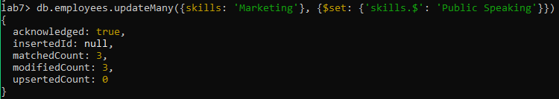

|  |  |
| --- | --- |
|  |  |
| Before | After |

Task 7) Add "Sports" element to skills array where id=3

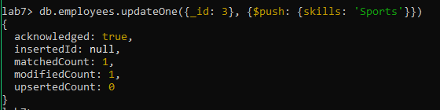

|  |  |
| --- | --- |
|  |  |
| Before | After |

Task 8) Add "Sports" and "Acting" to all skills arrays

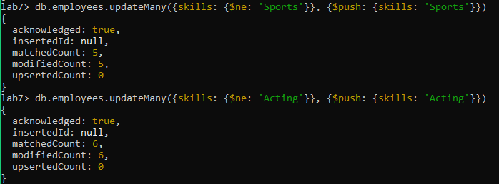

|  |  |
| --- | --- |
|  |  |
| Before | After |

Task 9) Add "GST" to all skills arrays if not exist

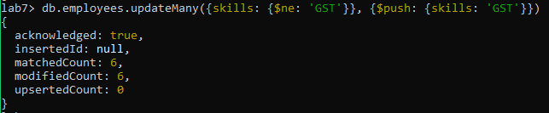

|  |  |
| --- | --- |
|  |  |
| Before | After |

Task 10) Remove the first element of all skills arrays

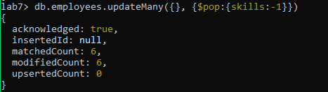

|  |  |
| --- | --- |
|  |  |
| Before | After |

Task 11) Delete all documents from the employees collection where salary=7000



|  |  |
| --- | --- |
|  |  |
| Before | After |

Task 12) Delete all documents where salary is less than 7000



|  |  |
| --- | --- |
|  |  |
| Before | After |